## CMS Commander

### Usage:

Install the windows setup file “Setup CMS Commander.exe” that will install the program itself, documentation and a Sitecore package that will enable additional services that this program requires.

Before running the CMS Commander please install the ”CMS Commander” Sitecore package to your Sitecore site, the package “Sitecore webservice installer.zip” will be located in “My Documents\CMS Commander” folder on your computer, if you have already installed the "Setup CMS Commander.exe" windows setup file.  
Install the sitecore package:

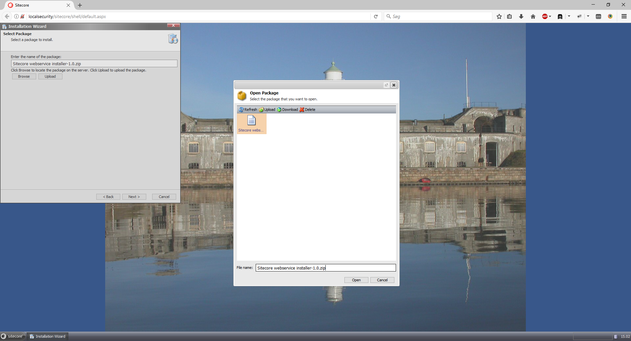

Then launch CMS Commander and start entering the address of the desired website that you want to connect to, and click the connect button.

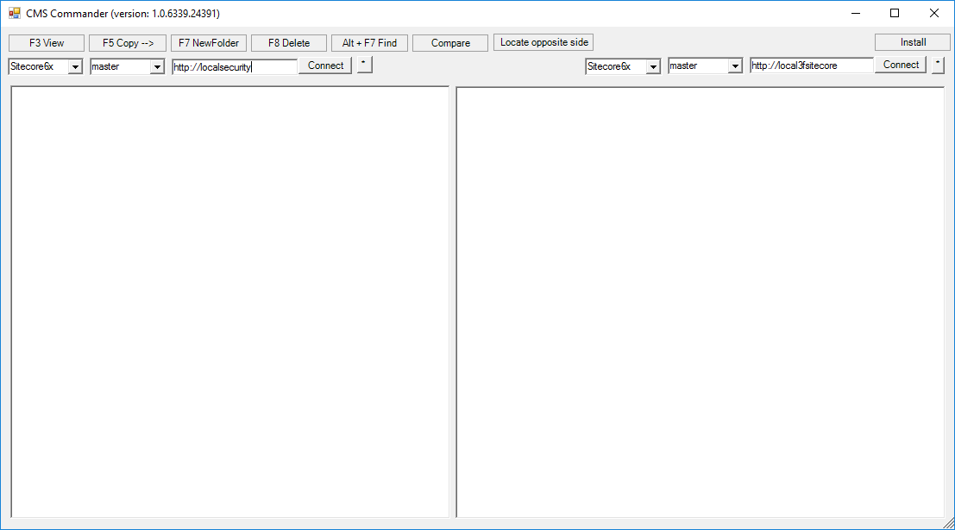

Enter user name and password, the user needs to have administrator rights:

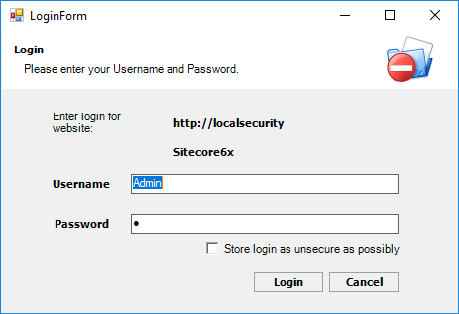

Then you should be greeted with the standard Sitecore tree:

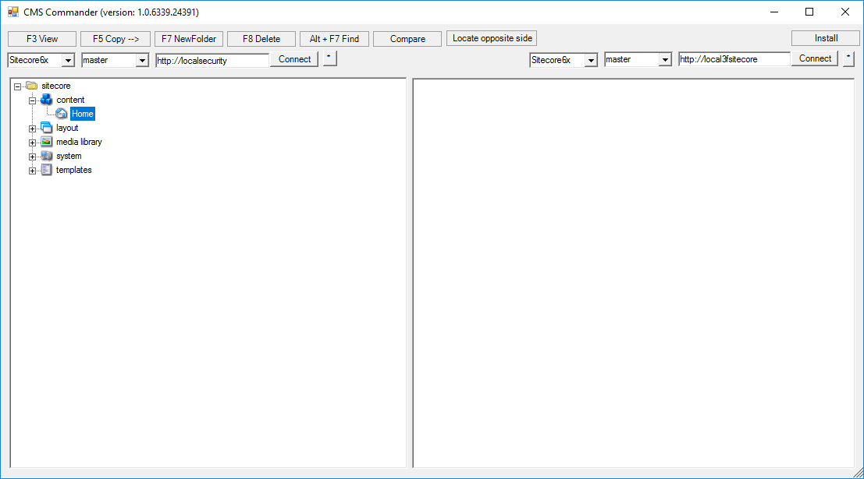

And you can log into another site in the opposite pane, so that you are now connected to two different sites:

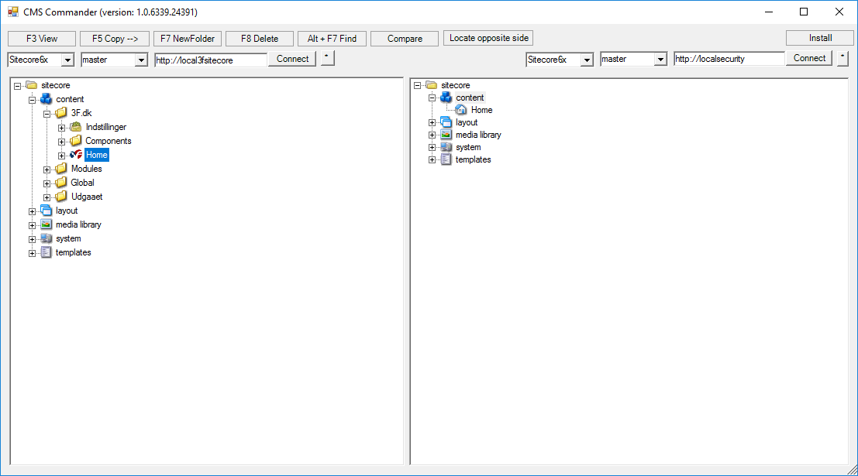

Select which item that you want to copy and which item you want to be the copy destination, by selecting a node in both panes.

Selecting copy in the left pane brings up the dialog below:

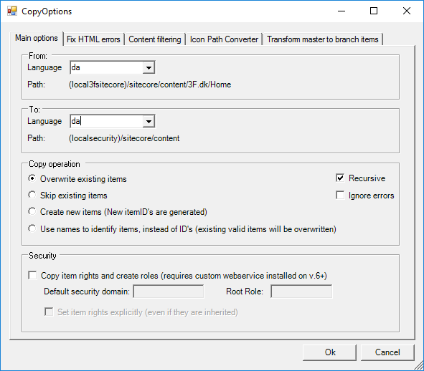

The default operation is to overwrite existing items by keeping the same ID, note this will also overwrite items if they exist at another path and have the same ID as the source items.   
Skip existing items will also copy and keep the same ID, however it will skip all the existing items on the destination, useful for updating new items.  
Create new items will copy items using the source path to create the same hierarchy of items at the destination, but will generate new ID’s for each item. This will never overwrite existing content.  
Use names to identify items will copy using the source path to create the same hierarchy of items at the destination, but will keep the destination ID’s for each existing item. Only useful for overwriting content where you are unsure whether it has the same ID as the source site.

Extra options include “Recursive” which defaults to checked, so that all the children of the selected source element are included in the copy operation.

Clicking the Ok button will start the copy operation.

## Notes:

It is preferred that only content is selected for copy operations, because then the program will automatically copy the needed templates and only the templates that are actually used will be created at the destination site.

Media library items are not automatically copied with the content items, so they will have to be copied manually but the media data will be copied when the media item is copied. However, it is strongly recommended to keep the media items ID’s when copying them, otherwise content items will no longer be linked correctly to their media items at the destination site.